2026 Buddy Boys Golf Guide
Entry:
- Entries are open to all.
- A minimum of 12 golfers for game.
- Event reservations are for 6 tee times (24 players). If entries exceed 24 players, and there is availability, a seventh (7th) tee time will be secured, but not guaranteed.
- Should there be more entries than availability, priority will go to the member with the number of events played, most to least.
- Groupings are posted the Monday before the event. All cancellations after the Tuesday before the event will place that player on the stand-by list for the following event.
- New player eligibility: In the initial two (2) events, the player will not pay an entry fee and will not be eligible to score in the event. The player will have the option to enter the Skins games and Closest-to-Pin for a fee of seven dollars ($7.00).
***New Player – A player with no previous events played in Buddy Boys Golf, or former player with no events played within the previous calendar year. ***
Fees:
- Greens fees are the responsibility of each golfer.
- Entry fee for the game will be a sum of $15.00, $10.00 game, $5.00 going to side skins games.
Payouts:
- Game payout: First place equals 40% of total game pool, second place equals 25% of total game pool, third place equals 20% of total game pool, and forth place equals 15% of total game pool. Ties equal combined payout for tied positions. Some monies may be moved for rounding purposes.
- Skins payout: Equals total pool divided by total number of gross skins. Only gross skins count toward skins pool pay-out. If there are no skins for an event money will carry over to following event. Some monies may be moved for rounding purposes. Par or better to win.
- Closest to pin payout: Equals maximum of $5.00 per par 3. Measures from the pin to front of ball. CTP money will be taken off the top of game entry. Par or better to win.

Games:
Stableford (net scoring)
- Albatross = 5 points
- Eagle = 4 points
- Birdie = 3 points
- Par = 2 points
- Bogey = 1 point
- Double bogey = 0 points.
- Triple bogey = -1 point

Stoke play (net scoring): The last Friday of each month will be a “net” game.

Rules of Play:
*** It is the responsibility of each player to protect the field. ***
USGA rules apply to all situations unless stated otherwise.
ELIGIBILITY: Game is open to any amateur who has an active USGA GHIN®. A player without a GHIN will play to a zero index until GHIN is established.
TEES TO PLAY: Two tees will be designated for play, determined by game official. Each player will have the choice of playing forward or back tees at each event. Choice must be made before starting the round and must be played the entire round.
FIRST TEE: A “breakfast” ball will be allowed only on the first hole of the round. However, if a player chooses to play a “breakfast” ball, it becomes the official ball in play.
MAXIMUM SCORE: A maximum score of triple bogey on all holes. Par threes = 6, par fours = 7, par fives = 8. *** Amended May 22, 2026***: Maximum score on all holes is 9.

PLAY the BALL AS IT LIES unless noted prior to the start of play. The ball must be played as it lies, except as otherwise provided in the rules.
- You may roll your ball at any point within the boundaries of the course up to the width of the scorecard.
- A player may rake and place a ball in the sand traps.
- A player may lift, clean. and replace their ball but only in the fairway of the hole being played.
SCORING: One player from each group will use the Squabbit app to keep the gross score of each player in that group. As a back-up, each group is assigned a scorecard. Each scorer then keeps the gross score of each player. A hole is not completed until the player’s ball is holed-out (no gimme), or a maximum triple bogey is achieved. At the completion of the round the net score and points will be calculated and posted.

****It is highly recommended that each player download the Squabbit app.****

CLOSEST TO THE PIN: A tape measure is provided for each group. Closest to the pin is measured from the pin to the ball. A player’s ball must be on the green in regulation to be measured and the player must par or better the hole to win. Measurement is entered into Squabbit with player’s name. If no player scores a closest to the pin on a given hole, that payout money will be carried over to the next hole won.
SCORE CARDS: A score card is deemed to be returned (no more changes allowed) when the score(s) have been posted on the official scoreboard. No alteration to a card may be made after it has been returned to the committee. The official-in-charge is responsible for applying course handicaps to scores.
OUT OF BOUNDS: Defined by the line between the course-side points, at ground level, of white stakes or fence posts; by white lines on the ground that connect stakes or roads; by the course-side edge of paved roads and beyond, even if ball comes to rest on another part of course. OB will be played as a lateral hazard (See rule regarding red penalty area).

IMMOVABLE OBSTRUCTIONS CLOSE TO PUTTING GREEN (BALL IN GENERAL AREA CUT TO FAIRWAY HEIGHT): Relief from interference by an immovable obstruction may be taken under Rule 16.1. In addition, if the player’s ball lies off the putting green and in the general area cut to fairway height and an immovable obstruction within two club-lengths of the putting green and within two club-lengths of the ball intervenes on the line of play, the player may take relief under Rule 16.1.

Gallery Rule: If a ball is believed to be in play and can not be found, upon agreement of the entire playing group, a player may drop in an agreed area of landing, no closer to the pin, without penalty. This rule may only be used on a tee shot.
GROUND UNDER REPAIR: Defined by white lines. Ground under repair also includes French drains, which are trenches filled with rocks or stones and newly trenched, newly sodded, or areas where course work is clearly being performed. If questionable, the playing group, as a whole, will make the decision.
WOOD CHIPS, MULCH AND PINE NEEDLES: Are loose impediments.
YELLOW PENALTY AREAS: Defined by yellow stakes and/or lines. Two options for relief; 1. Stroke and distance. 2. Back on line.
RED PENALTY AREAS: Defined by red stakes and/or lines and includes unmarked drainage ditches and other open water courses. Treat all penalty areas as red penalty areas unless otherwise marked. Three options for relief; 1. Stroke and distance. 2. Back on line. 3. Lateral relief.

*** Every player should be familiar with the Rules of Play ***

HANDICAPPING AND ADJUSTMENTS: If a player has less than 20 rounds posted in GHIN, or less than 20 rounds posted in the past 6 months, the following will apply, source USGA 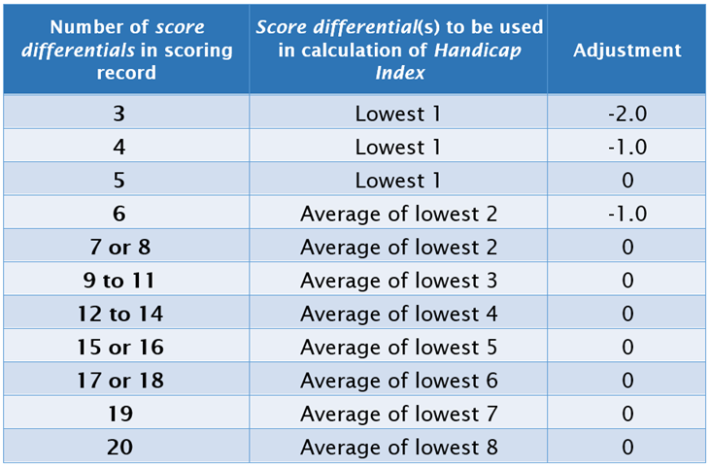

Event Points System

In order to better serve our participants, we have developed and deployed an Event Points System that helps our team better monitor handicapping for those that consistently finish at the top of the leaderboard.

- First place = 5 points
- Second Place = 4 points
- Third Place = 3 points
- Fourth Place = 2 points

Once their EPS point total reaches a certain level the reduction is then applied to the event index for that participant. This reduction will be applied to the next two events played. The levels of reduction are detailed below.
- 10 total points is a 3 stroke reduction
- 8 total points is a 2 stroke reduction
- 6 total points is a 1 stroke reduction

The events included to attain points are the last three events played. If participants placed in the top 4 in all 3 of these events, then the 2 best finishes will be utilized.
*Event Points System subject to change at any time.

2026 Schedule

January 2 Parkland 6 tee times double tee 8:28
January 9 Meadowlands 6 tee times double tee 9:32
January 16 Whisper Pines 6 tee times single tee 9:00
January 23 Brunswick 6 tee times single tee 9:40
January 30 Heathland 6 tee times double tee 8:28
February 6 Meadowlands 6 tee times double tee 8:32
February 13 Whisper Pines 6 tee times single tee 9:00
February 20 Brunswick 6 tee times single tee 9:32
February 27 Parkland 6 tee times double tee 8:28
March 6 Myrtlewood Palm 6 tee times single tee 8:42
March 13 Whisper Pines 6 tee times single tee 9:00
March 20 Brunswick 6 tee times single tee 9:00
March 27 Moorland 6 tee times double tee 7:48
April 3 Wild Wing 6 tee times single tee 8:24
April 10 Whisper Pines 6 tee times single tee 9:56
April 17 Pinehurst Week no event
April 24 Azalea Sands 6 tee times single tee 8:42
May 1 Colonial Charter 6 tee times double tee 8:00
May 8 Whisper Pines 6 tee times single tee 9:00
May 15 Brunswick 6 tee times single tee 9:08
May 22 Aberdeen 6 tee times double tee 8:24
May 29 Azalea Sands 6 tee times single tee 8:18
June 5 Whisper Pines 6 tee times single tee 9:00
June 12 Brunswick 6 tee times single tee 8:52
June 19 Oyster Bay 6 tee times double tee 8:28
June 26 Meadowlands 6 tee times double tee 8:02
July 3 Whisper Pines 6 tee times single tee 9:00
July 10 Brunswick 6 tee times single tee 8:52
July 17 Parkland 6 tee times double tee 8:28
July 24 Aberdeen 6 tee times double tee 8:24
July 31 Whisper Pines 6 tee times single tee 9:00
August 7 Brunswick 6 tee times single tee 7:32
August 14 Kings North 6 tee times double tee 8:33
August 21 Meadowlands 6 tee times double tee 8:26
August 28 Whisper Pines 6 tee times single tee 9:00
September 4 Brunswick 6 tee times single tee 8:52
September 11 Myrtlewood P H 6 tee times double tee 8:48
September 18 Aberdeen 6 tee times double tee 8:48
September 25 Whisper Pines 6 tee times single tee 9:00
October 2 Brunswick 6 tee times single tee 9:08
October 9 Southcreek 6 tee times double tee 8:33
October 16 Arrowhead 6 tee times single tee 8:51
October 23 Whisper Pines 7 tee times single tee 9:00
October 30 Brunswick 6 tee times single tee 9:16
November 6 MBN West 6 tee times double tee 8:34
November 13 River Hills 6 tee times double tee 8:36
November 20 Whisper Pines 6 tee times single tee 9:00
November 27 Thankgiving no event
December 4 Arrowhead 6 tee times double tee 11:42
December 11 Wild Wing 6 tee times double tee 8:45
December 18 Meadowlands 6 tee times double tee 8:26

